Off-Line Handwritten recognition using fuzzy logic and genetic algorithm

Abstract

This paper discusses about the recognition of handwritten characters of English and Kannada. In particular we concentrate about the hybrid technique which is used in here. This approach uses two algorithms which are genetic and fuzzy logic for recognition.Feature extraction is the estimation of certain attributes of the target patterns. Selection of the right set of features is the most crucial and complex part of building a pattern recognition system.The novelty of this approach is to achieve better accuracy and reduced computational time for recognition of handwritten characters using Genetic Algorithm which optimizes the number of features along with a simple and Fuzzy Logic. We will analyze the performance and accuracy of the system.

Keywords: Pattern recognition, Genetic algorithm, Fuzzy Logic, Feature Extraction.

# Introduction:

Off-Line handwritten recognition, often referred as optical character recognition, is performed where the converting of handwritten document to digital form is completed. The main advantage is it can be done at any time after the conversion process is completed even after many years. The disadvantage is it cannot be done in real time.

The application of handwritten recognition systems is Digital Character conversion, Meaning Translation, Content Based Image Retrieval, Keyword Spotting, Signboard Translation, Text-to-Speech Conversion, Scene Image analysis. Furthermore, OCR plays an important role for digital libraries, allowing the entry of image textual information into computers by digitization, image restoration, and recognition methods.

Offline handwriting systems generally consist of four processes: acquisition, [segmentation,](https://www.sciencedirect.com/topics/social-sciences/segmentation) recognition, and post processing (Fig 1.1). First, the handwriting to be recognized is digitized through scanners or cameras. Second, the image of the document is segmented into lines, words, and individual characters. Third, each character is recognized using OCR techniques. Finally, errors are corrected using lexicons or spelling checkers.

Offline handwriting recognition systems are less accurate than online systems because only spatial information is available for offline systems, while both spatial and temporal information is available for online systems.

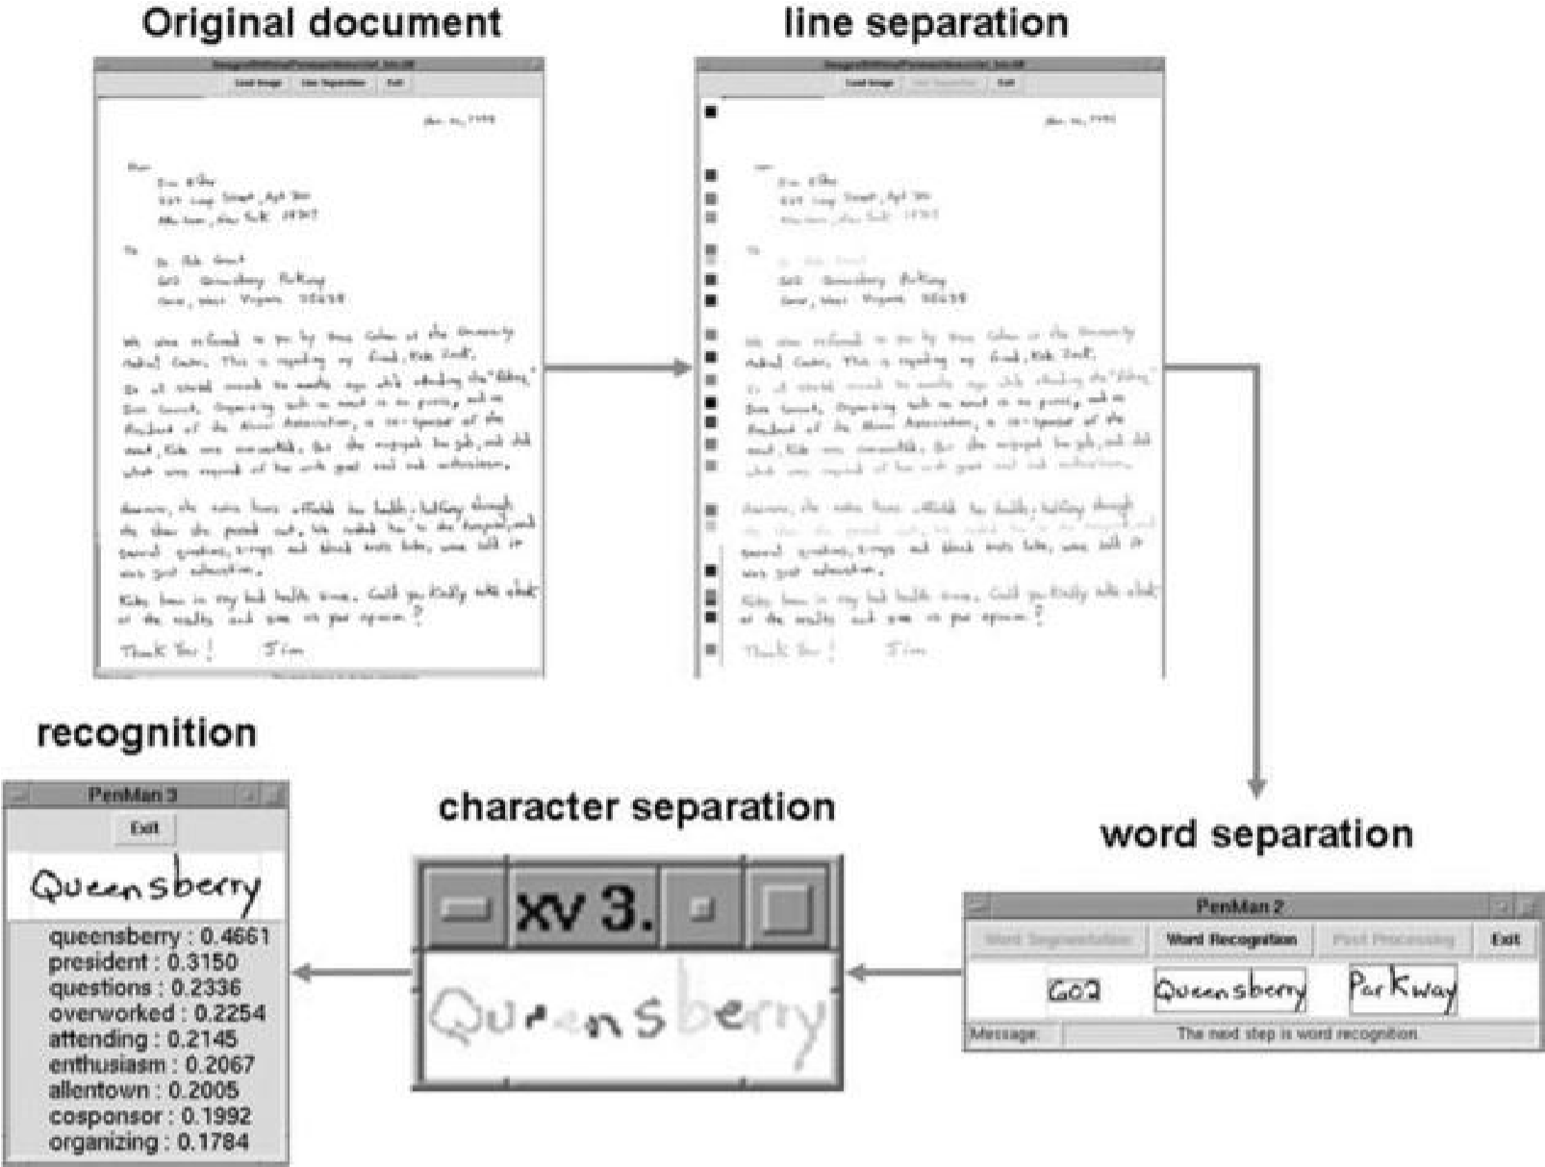

Figure 1.1. Offline handwriting recognition processes.

# Background:

Handwritten recognition is converting handwritten text to a notable representation. It is a domain of pattern recognition and machine intelligence. Hand written recognition can be of two types: Online and Offline – Which will be dependent on the type of the data availability.

In Online character recognition the parts which are identified will be written by smart pen or tablets where as in offline recognition the characters are written in paper with pens and then it is scanned into digital pictures [1].

What Offline character recognition does is, the image of writing will be converted into bit pattern by a device like scanner or camera; the recognition will be done on this pattern of bits for both printed or hand written [2]. Off-line handwritten character recognition continues to be an active research area towards exploring the newer techniques because it has various applications such as postal sorting, bank cheque amount reading, and official document reading [3].

Feature Extraction plays an important role in any character recognition to classify the character’s patterns efficiently. A feature is nothing but a property which can be used for representing different shapes and symbols. Every machine learning algorithms uses a set of features for the classification purpose [4]. The fundamental task of the feature extraction is to find out the most useful features for classification; that is, compressing from high to low dimensional feature space, so as to design the classifier very effectively [5].

## 1.2. Statement of the problem

Handwritten recognition is used for many applications in our real world, but there are many algorithms and many techniques such as classical and soft computing techniques. In this paper we will be trying out the soft computing technique. Some of the algorithms in soft computing techniques are artificial neural networks, Fuzzy logic, Genetic algorithms, particle swarm optimization etc. There are many implementation on this topic, OCR have been implemented with neural network and tensor flow which has given them an accuracy of 90% [6]. Handwritten Text recognition with the applications of NLP has achieved an accuracy of 92.7% [7]. The hill climbing approach used for handwritten recognition has gained an accuracy of 93% for the uppercase letters and they have used hill climbing algorithm for the feature selection [8].In some the researchers has proposed fuzzy model on numerical recognition which had an accuracy of 95% for Hindi and 98.4% for English numerical [9] and in another paper for Hindi numerical the method used is Bacterial Foraging, the accuracy they have got is 96% [10]. Here we are going to implement fuzzy logic and genetic algorithms to the handwritten recognition.

## 1.3. Objectives:

Here we will be using fuzzy logic and genetic algorithms on offline handwriting recognition (OCR). We will examine the performance of the two algorithms on OCR. What will be the accuracy of the following algorithms in that? For the feature extraction we will be using genetic algorithms and analyze how the algorithms performs on the OCR.

This paper will gives us an emphasis on the feature selection process and the performance of the algorithms on OCR, proposed a genetic algorithm for the feature selection technique for OCR.

# Methodology:

A hybrid feature set of statistical and geometrical features is developed in order to get the effective feature set consist of local and global characteristics of sample digits. The method utilizes a genetic algorithm based feature selection for selecting best distinguishable features and fuzzy logic for evaluating the fitness of features of handwritten digit dataset.

Block Diagram:

**Input Image**

**Binarization**

**Noise Removal**

**Smoothing**

**Resizing**

**Feature**

**Extraction**

**Feature Selection**

**using GA**

**Fuzzy Logic**

**Output**

**Expected Outcome:**

The experiment results should show the effectiveness of the proposed approach. The experiments will be carried out on standard The Chars74K handwritten digit dataset must achieve good results without sacrificing the recognition accuracy.

The Chars74K handwritten digit dataset page :

<http://www.ee.surrey.ac.uk/CVSSP/demos/chars74k/>